Cade Stephens

Cs 5300

Normalizer project

Code Description  
  
 First a general description of my code. I used Python language with a few imported tools such as Pandas. I built my program to read as an input a .xlsx file that must be made in a specific format. I will describe its format later. Once the program reads the input.xlsx it will parse through the given data and store it as a relation and store all that data for the normalization process. After this the program will prompt the user to type 1-6, correlating to 1st-5th normal form. 1st -4th work, but i was unable to get 5th normal form to work. After you select which form, it will step through each form and normalize it 1nf to your selected final. After that it will print out each table with its keys and elements one at a time and let you rename the tables, which is necessary since the auto-naming is not meant to be comprehensible and really just a placeholder. After that it will print out every table with its new name. They look like the image below shows this all.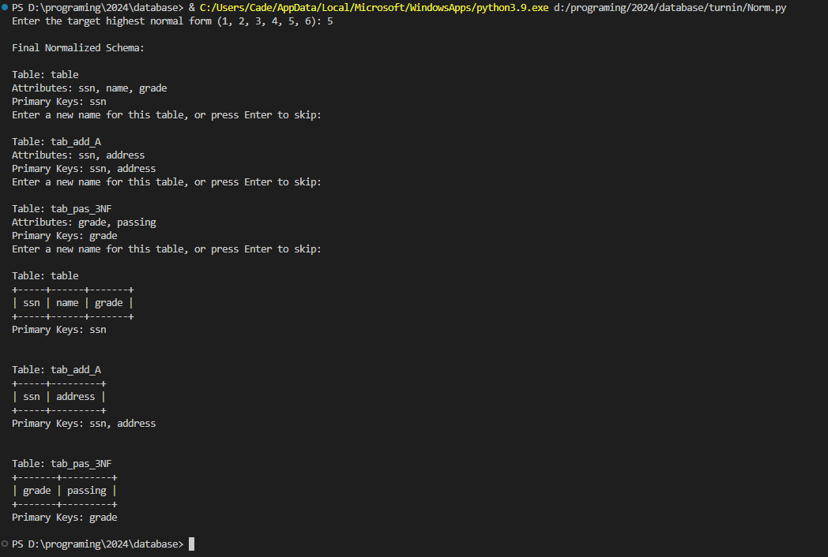

The image below also shows the table renaming for most of the 4nf tables of the sample data.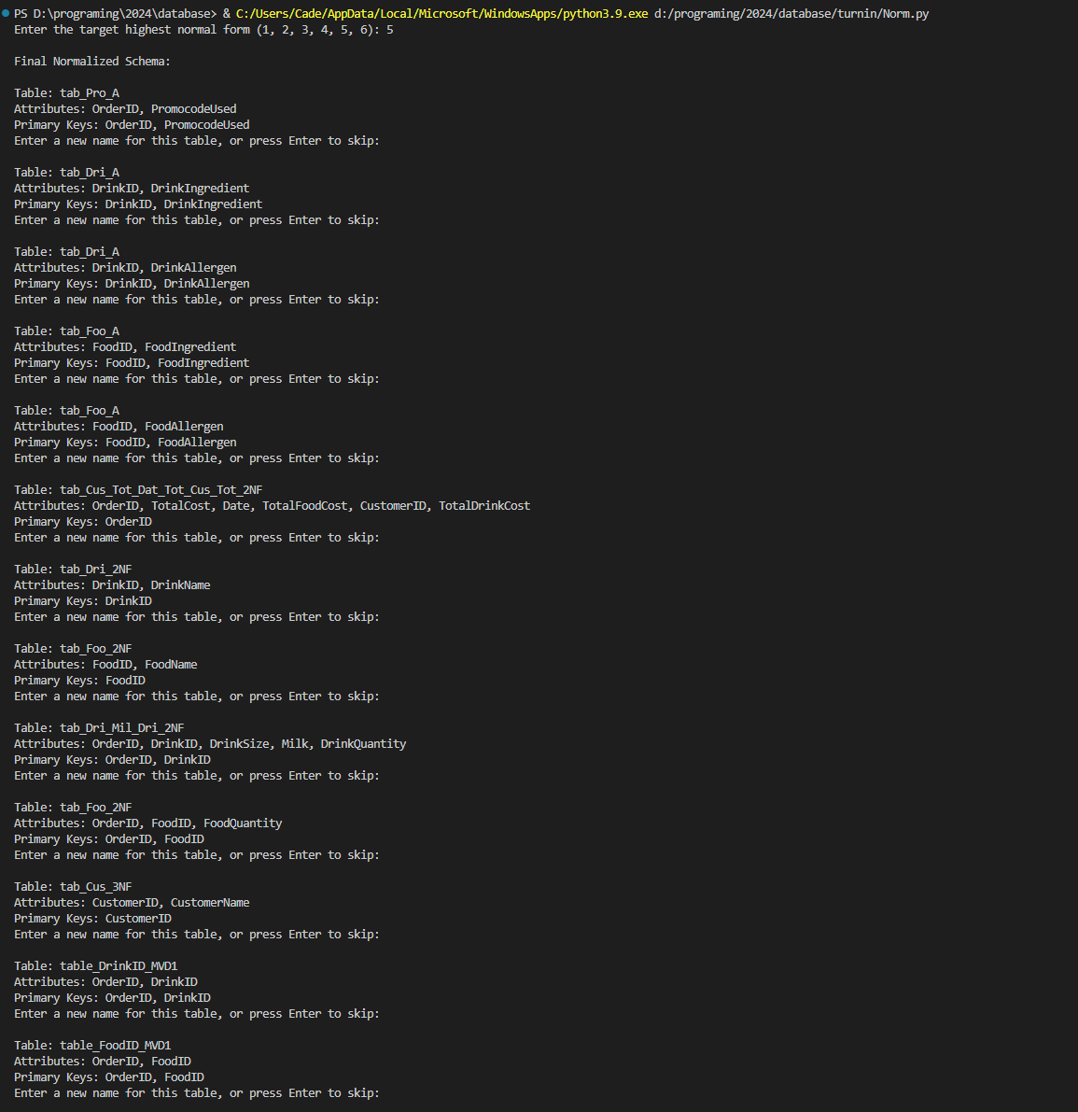

Now, regarding the format of the XCEL sheet. I went with this because it was very easy for testing and much more practical than typing into the console all that data. Originally I did have the console input and just had a hardcoded test option, but this was much cleaner and more useful. The first row in col A is for the amount of attributes. Row 2 is for the amount of data tuples. 3 is for the table name. 5 is for the row of attributes, and the next x rows for the data tuples. Then 3 rows after the last tuple is the primary key in the format “Primary Key: {OrderID, DrinkID, FoodID}”, with a solo key just having no {}. The below is the candidate keys in the format “Candidate Keys: None”. Then 2 rows below in col B is the FD’s in the format of “OrderID --> PromocodeUsed (a non-atomic attribute)” and “OrderID --> {Date, TotalCost, TotalDrinkCost, TotalFoodCost, CustomerID, CustomerName}” and “OrderID -->> {DrinkID, FoodID}”.

